Estimation of animation parameters using behaviour pattern
Domen Mongus and Blaž Repnik
Laboratory for Geometric Modeling and Multimedia Algorithms
Faculty of Electrical Engineering and Computer Science, University of Maribor
Slovenia

Abstract
In this paper a genetic approach for calibrating parameters of textile animation program is presented. The animation of textile uses a particle system based on Verlet integration. The parameters of the animation model are the stiffness of the springs connecting the particles. The characteristics of real textile are measured by drapemeter which generate the drape curve. This curve is compared against the computer generated curve. The parameters of this curve are calibrated by a genetic algorithm. The results show that the matching of curves has been found in the majority of cases. The approach can be evaluated as successful unless the time needed for the calibration is not important.

Keywords: simulation, textile animation, particle system, collision detection, similarity measurement

Introduction
A set of different parameters is often used in animations for describing dynamic behaviour of objects. Estimation of these parameters is of critical value for imitation of real-world phenomena. In this context, an animation can be addressed as simulation.

Simulation is a situation in which a particular set of conditions is created artificially in order to study or experience something that exists in reality. [1]

The simulation presented in this paper is used to observe the behaviour of textile in various conditions, like gravity, wind, and movement of objects. It is based on a particle system defined by a set of points connected with springs. Stiffness of springs controls the movement of points under the gravity, or after the collision with objects or wind.
Our objective is to estimate the correctness of spring stiffness to obtain real textile behaviour. For animation, the simulation model is too complex to determine the stiffness parameters analytically. It is very difficult to define such a system and very time consuming to obtain the parameters, which would describe real materials.
In this paper we present a method for calibrating animation to obtain the realistic pattern of textile behaviour. In this context we define the similarity measurement between the patterns obtained from reality and from our simulation method based on a genetic algorithm.

Particle system for textile animation
The behaviour of a textile is frequently simulated by particle systems in computer graphics [2, 4, 6, 8]. A particle is a structure with mass, velocity and position that move under the influence of different forces, e.g. gravity, springs, user interaction, wind, collision response etc. The task of the algorithm is to calculate a new particle position for every time-step. We do this by using numeric integration called Verlet integration (eq. 1):
$x_{\text{new}}=2x−x_{\text{prev}}+{\text{dt}}^{2}a$ (1)

Where:

- a is acceleration calculated with Newton's formula a = f / m. f represents a resultant of string forces influencing the current particle,
- x_{prev} is particle's previous position,
- x is current position of a particle,
- x_{new} is the new position of the particle, and
- dt is the time-step of this simulation. After each time-step, the current position of the particle is stored as the previous position (eq. 2):

$x_{\text{prev}}=x\text{.}$ (2)

Every simulation frame consists of the following steps:

- Determination of resultant of forces: forces affecting the particles must be computed and considered for each particle for every frame.
- Verlet integration: after we have the resultants, Verlet integration is applied to obtain the new position for each particle.
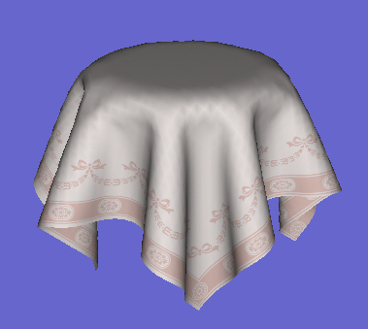
- Satisfaction of constraints: In this step, the constraints between particles are considered. As a result of particle movement, some springs either squeeze or either expands. The particles are moving until the stable state is achieved. The process of calculating the new particle positions is carried out as an iterative process. All particles that are connected to the considered particle are visited. The movement vector of the considered particle (denoted as x_{1new}) is determined by eq. 3, and the movement vector for the influencing particle (denoted as x_{2new}) is calculated by eq. 4.

$x_{1_{\text{new}}}=x_{1}+\frac{d f}{K m_{1}},$ (3)
$x_{2_{\text{new}}}=x_{2}+\frac{d f}{K m_{2}},$ (4)

$d=x_{2}−x_{1}\text{.}$ (5)

Explanation:

- x₁ and x₂ are the positions of two particles, which are connected by the spring,
- d is a vector pointing from the first particles position to the second particles position; its length represents current length of the spring obtained by eq. 5,
- f is the amount of force needed that the spring returns to the neutral state. It is calculated by using current length of the string |d|, its length in the neutral state L_{n} and the masses m₁ and m₂ of both particles. f is calculated according to eq. 6.

$f=\left|d\right| −\frac{L_{n}}{\left|d\right|}(m_{1}+m_{2})$ (6)

Every particle in this system is connected to its neighbours by three types of springs as shown in Figure 1. The black ones prevent unwanted stretching, the green ones prevent shearing, and the red ones prevent bending. The main goal is to set proper stiffness of those springs to get correct system behaviour.

Figure 1: Particle system with variable stiffness of springs.

The result of described configuration is shown in Figure 2, where all springs stiffnesses are set to the same value. The problem with this tablecloth is that we cannot simulate different kind of material it represents, since our simulation has not been calibrated yet.
Figure 2: Cloth over the tablecloth - particle system with default settings.

In our implementation, the collision detection between the table and the tablecloth has been implemented, too. To speed-up this process, an octree has been applied [3, 5] (see Figure 3).
Figure 3: Octree is applied at collision detection.

Evaluation of textile characteristic
To get the basic knowledge, how to determine the characteristics of textile, we have established cooperation with the Laboratory for Clothing Engineering, Physiology and Construction of Garments at Department of Textile Materials and Design, which is a part of Faculty of mechanical engineering at University of Maribor. Different methods exist for determining the characteristics of textile [9], but for our purposes the method based on a drape was the most suitable. The drape is defined as “an extent to which a textile/fabric will deform when it is allowed to hang under its own weight” [9]. In textile industry, a drape is a critical characteristic which determines how textile conforms to objects under the influence of outside forces. It prescribes the textile deformation under the gravity, revealing many of material’s characteristics like its rigidity and flexibility. The drape of a textile is measured by a drapemeter. The drapemeter is a device which lets textile fall on the rounded table, eliminating as much of the external factors as possible [10]. For this purpose the measurement is done under controlled environment where external factors such as wind and chance of human influence are eliminated. The drapemeter consists of a dropping mechanism which excludes the human interference, and rounded table onto which the cloth is dropped. The diameter of the table is usually 15 cm and the diameter of the textile is 30 cm. The textile is illuminated with special light to eliminate disturbance factors coasted by different colours of the fabrics. The result of measurement is a digital image of the textile taken by a digital camera connected to the computer. In Figure 4 a result of such test is shown. The characteristic of the textile is the corrugation of drape curve.
Figure 4: Digital image of fabrics drape created by digital drapemeter

The main idea of this work was to establish the link between the real material and the computer animation of textile. For these purposes the computer simulation of the drapemeter has been done. The main presumption is whether the drape obtained from the computer model fits the drape obtained from the drapemeter, the computer model should behave as a specific textile.
In Figure 5 the result of computer animated drape is shown.
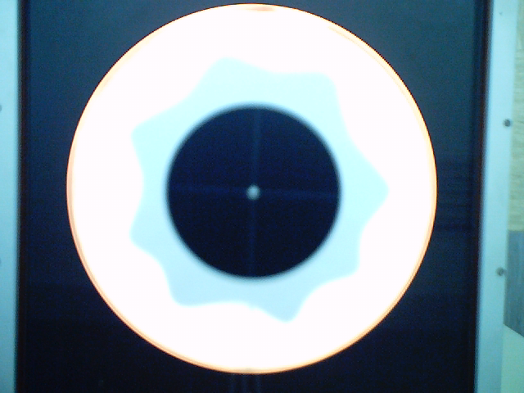

Figure 5: Drape obtained from simulation

Matching drape curves
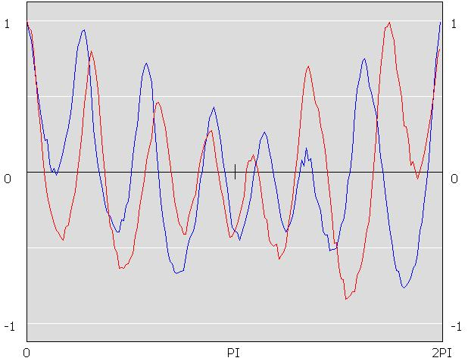
For comparison, the curves obtained from the drapemeter and from the computer simulation can be observed as a signal in time space. Therefore, both connected curves have been developed as shown in Figure 6.
Figure 6: Two flat-curve deployed contours of same material.

At first, the curve from drapemeter has been recognized as a border between the object and background as shown in Figure7.
To form the contour, a ray form the centre of the object in a given angle has been sent, and the distance from the centre to the border of the curve has been determined. When the rays form the whole circle, the curve has been determined.
To compare two signals, they are usually transformed in to the frequency space. Fast Fourier transformation has been applied for this purpose.
We have performed a lot of tests and we have concluded that the contours of the same materials have very similar frequency spectres. In this way, the contours produced by different materials can be very reliably differentiated.
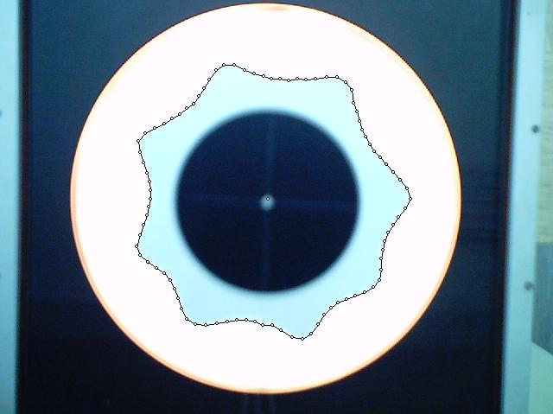
Figure 7: Recognition of contour from the centre of the object
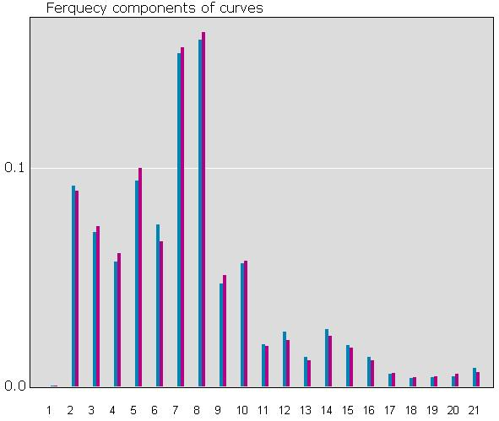
Figure 8: Comparison between curves in frequency space

In Figure 8 we can see the comparison in frequency space between the two curves from Figure 6. Even though they are fairly different in time space because of the phase shift, their frequency components are practically the same. This approach is independent of rotation and translation of the curves. The location of the centre point has also no noticeable impact on curve development. If the centre point is moved the results of the similarity test is practically the same. We have noticed only a small deviation of the first harmonic component, which has been absorbed by higher harmonic components. At the end, the frequency components of the two curves are normalized and compared. For curves in Figure 6 and Figure 7 the similarity is almost 99%.

Validation of similarity measurement
We have used eight different textiles for tests. For each textile sample, three drape measurements have been done by the drapemeter. In Table 1 the measurements of similarity between different images of the same textile sample are given. High level of similarity has been achieved except for the material Cotton/757, where we have discovered that the image obtained from the drapemeter was partially damaged.

Fabrics / Specimen | Average similarity | Absolute tolerance
Cotton / 699 | 93% | 5%
Cotton / 757 | 77% | 39%
PES – EL / 479 | 95% | 4%
WO-EL / 515 | 93% | 6%
PES / 112 | 97% | 2%
PES / 230 | 86% | 5%
Wool / 456 | 92% | 4%
Wool / 458 | 94% | 3%
Average | 91% | 4%
Table 1: Similarity measurement of contours produced by same fabrics

To accept the method as useful, the results achieved of similarity measurement between different textiles should be low. The results of this comparison are presented in Table 2. It can be seen, that the results of comparison are noticeable lower than in Table 1, what gives us possibility to reliable classify the materials. In our case we suppose that the materials are the same, when the level of similarity is above 90% and they are different, if the similarity level is below 80%, results in-between are rated as inconclusive.

Fabrics / Specimen | Fabrics / Specimen | Average similarity
Cotton / 699 | Cotton / 757 | 76%
Cotton / 699 | PES – EL / 479 | 77%
Cotton / 699 | WO-EL / 515 | 68%
Cotton / 699 | PES / 112 | 66%
Cotton / 699 | PES / 230 | 76%
Cotton / 699 | Wool / 456 | 74%
Cotton / 699 | Wool / 458 | 73%
Cotton / 757 | PES – EL / 479 | 74%
Cotton / 757 | WO-EL / 515 | 68%
Cotton / 757 | PES / 112 | 66%
Cotton / 757 | PES / 230 | 73%
Cotton / 757 | Wool / 456 | 76%
Cotton / 757 | Wool / 458 | 77%
PES – EL / 479 | WO-EL / 515 | 74%
PES – EL / 479 | PES / 112 | 73%
PES – EL / 479 | PES / 230 | 75%
PES – EL / 479 | Wool / 456 | 76%
PES – EL / 479 | Wool / 458 | 74%
WO-EL / 515 | PES / 112 | 73%
WO-EL / 515 | PES / 230 | 64%
WO-EL / 515 | Wool / 456 | 63%
WO-EL / 515 | Wool / 458 | 67%
PES / 112 | PES / 230 | 68%
PES / 112 | Wool / 456 | 67%
PES / 112 | Wool / 458 | 69%
PES / 230 | Wool / 456 | 70%
PES / 230 | Wool / 458 | 73%
Wool / 456 | Wool / 458 | 74%
Average |  | 69%
Table 2: Similarity measurement of contours produced by different fabrics

Calibration
For setting the parameters of our animation algorithm, a genetic algorithm has been implemented. The highest match of two drape curves (the real one and those produced by our program) can be considered as finding the global maximum of a function – one of the basic problems in genetic algorithms. This is the process of calibration. The process of calibration is terminated, when the level of similarity reaches 95%.
The search space of the calibration process consists of all possible values of parameters, which may be used to describe the computer model of textile. The individuals in the population consist of six chromosomes and each of them carries the value of one spring parameter:
- stiffness parameters of two horizontal springs,
- stiffness parameters of two vertical springs, and
- stiffness parameters of two diagonal springs.
These springs connect the considered particle with its neighbours as seen in Figure 1. Individuals also sustain an estimation factor, which evaluates a particular set of chromosomes as a possible solution. As already stated, when an individual reaches the value of similarity 95% (or higher), the process is stopped and the individual is rated as a solution.
In the first stage of the calibration process the population is created. The values of chromosomes are determined randomly and the estimation factor of individuals is determined by a fitness function. The fitness function accepts an individual as a possible solution. It creates the simulation model based on description provided by chromosomes of an individual. After the simulation is run, the drape curve is obtained, and the similarity test is executed, as shown in Figure 9.
After that, the process of selection is executed. The implemented selection belongs to the tournament type, with one element to advance on proportional basis. In this way, we assure that at least one specimen of currently the best individuals in the population advances to the next generation regardless to the “luck” of being ruffled for selection tournament [12].

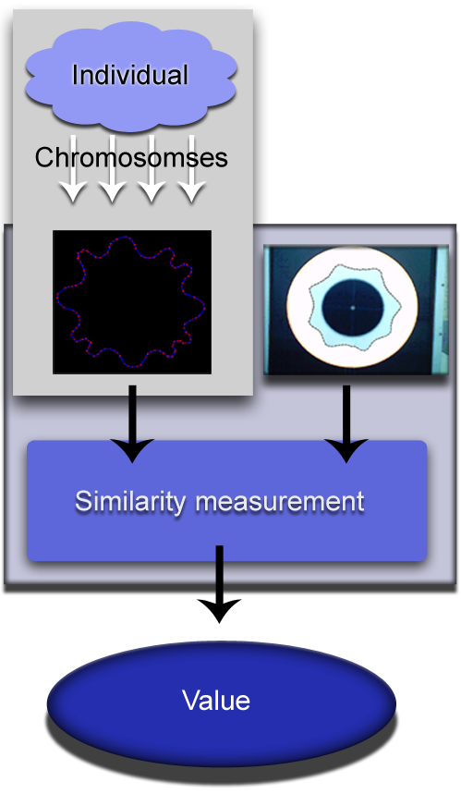
Figure 9: Schema of fitness function

Selection makes possible that the promising individuals reproduce themselves. In this way, the population is better from generation to generation. However, there is a risk of degeneration if the individuals progress towards the local maximum. To reduce this risk, the operation of mutation is included. Its purpose is to assure the diversity of the population. In our case the mutation is implemented as a random change of chromosomes. In one cycle of mutation there can be a change up to four chromosomes. In that way the diversion is created with the possibility of keeping some parent’s characteristics. Advancement of a parent from a previous generation tells that it contains some quality. If we can keep the quality of it, there are better chances for the mutated individual to last and to spread its diversity through the process of crossing.
In the implementation we have tested several types of crossing. Through counting evaluations we concluded, that the best way of crossing is random selection of chromosomes for each chromosome position. In creation of new individual the first two parents are randomly selected. Then the value of each chromosome is copied randomly from one of them.
Each new individual must be evaluated. The number of evaluations is counted and if the solution is not found in five thousand evaluations, we assume that the population is degenerated in such way that no mutation can provide enough diversity. The process is stopped and the attempt of finding the solution is ranked as failed.
As there is no analytical approach to define parameters of the genetic algorithm they have to be estimated experimentally. The main criterion of efficiency is the number of evaluations as the evaluation is the most costly. Through the series of tests we concluded that a large size of population is not needed as the stress of it is upon evolution of an individual and not on random searching through the space. The population size giving us the best results consists of forty individuals.
In our experiments, the probability of an individual to be selected for mutation is 0.15 and the probability of an individual to be created from crossing is 0.4.

Fabrics / Specimen | Runs | Failed runs | Successful runs
Cotton / 699 | 15 | 0 | 15
Cotton / 757 | 15 | 1 | 14
PES– EL/479 | 15 | 0 | 15
WO-EL / 515 | 15 | 0 | 15
PES / 112 | 15 | 0 | 15
PES / 230 | 15 | 0 | 15
Wool / 456 | 15 | 1 | 14
Wool / 458 | 15 | 0 | 15
Average | 15 | 0 | 15
Table 3: Number of failed and successful runs of parameter estimation for given textile

The results are shown in Table 3. As can be seen, the valid parameters have been obtained in almost every run. In Table 4 we can see the number of evaluations needed to achieve the solution.
Table 4 shows also on the weaknesses of the proposed approach. Though the solution is always found, too many evaluations are needed. An average time to calibrate the animation model takes an hour and half.

Fabrics / Specimen | Runs | Average number of evaluations | Highest number of evaluations
Cotton / 699 | 15 | 356 | 2645
Cotton / 757 | 14 | 378 | 1599
PES– EL/479 | 15 | 324 | 1364
WO-EL / 515 | 15 | 366 | 2218
PES / 112 | 15 | 312 | 1242
PES / 230 | 15 | 272 | 999
Wool / 456 | 14 | 391 | 3765
Wool / 458 | 15 | 455 | 1501
Average | 15 | 357 | 1916
Table 4: Number of evaluations needed to estimate valid parameters

Obviously, an alternative approach would be needed to reduce the number of evaluations. The use of neural networks would be an attractive possibility.

Conclusion
In this paper a method for calibration of parameters for textile animation is presented. The animation is based on a particle system using Verlet integration. The process of setting the parameters is related to measurement of textile characteristics. A very popular method for obtaining the physical parameters is the use of a drapemeter. As a result the drape curve is obtained. We compare the curves obtained from the drapemeter and from our animation program. The similarity of the curves is estimated at first. The parameters of the animation programs are calibrated by the help of genetic algorithm. The solution is found in the majority of cases, but the time needed to set the parameters is rather long. For this we intend to apply a neural network, which would be combined with existing genetic algorithm

References
- Stoanes C, Stevenson A. Oxford dictionary of English. Oxford University Press. London; 2005
- Aono M. A Wrinkle Propagation Model for Cloth. Proc. CG Int’l. Springer-Verlag. Berlin; 1990. p. 95-155.
- Klosowski JT, Held M, Mitchell JSB, Sowizral H, Zikan K. Efficient Collision Detection Using Bounding Volume Hierarchies of k-DOPs. IEEE Transactions on Visualization and Computer Graphics 1997; 4(1):21-36.
- Hockney RW, Eastwood JW. Computer Simulation Using Particles. Bristol: Taylor & Francis; 1988.
- Gottschalk S, Lin M, Manocha D. OBB-Tree: A Hierarchical Structure for Rapid Interference Detection; Proc. of ACM Siggraph'96; 171-180
- Jacobsen T. Advanced Character Physics. http://www.teknikus.dk/tj/gdc2001.htm [11/01/2008]
- Terzopoulos D, Fleischer K. Deformable Models. The Visual Computer 1988; 4(6): 306-331
- Verlet L. Computer experiments on classical fluids. Thermodynamical properties of Lennard-Jones molecules. Phys. Rev. 1988; 159(98): 98-103.
- British Standards Institution. 1974. Methods of Test for Textile. BS 5058:1973, B.S. Handbook No. 11, London, 1974
- Cusick GE 1968. The measurement of fabric drape. Journal of the Textile Institute, Vol 59, pp. 253-60
- Sivanandam SN, Deepa SN. Introduction to Genetic Algorithms. Springer, 2007
- Coley DA. An introduction to genetic algorithms for scientists and engineers. Word scientific publishing company, 1997

domen.mongus@uni-mb.si
blaz.repnik1@uni-mb.si

